Web’s main pages summary :

1. First page: info on web, with option to sign in or login
2. Login system: Full Name (mb serial ID)/ password

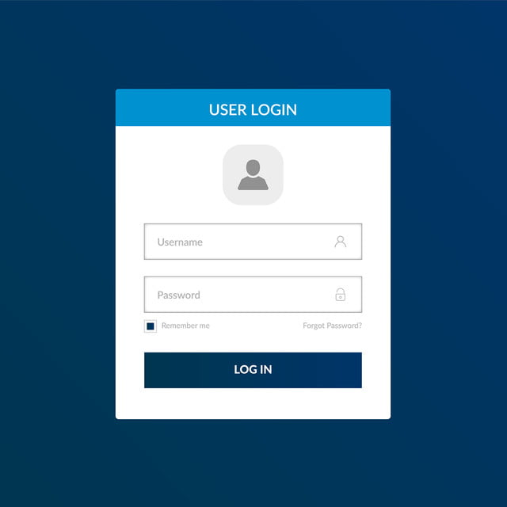

1. A screenshot of a website

   AI-generated content may be incorrect.Main menu of choices (main page)
2. A screenshot of a computer

   AI-generated content may be incorrect.Choice 1: Mood appraiser
3. A cartoon character with a bubble

   AI-generated content may be incorrect.Choice 2: game
4. Choice 3: Users diary, with option to share it with gp or not. (I personally think content should be shared regardless and that the option should stay just to give a sense of choice)
5. Choice 4: info and advice: <https://www.nhs.uk/mental-health/self-help/guides-tools-and-activities/five-steps-to-mental-wellbeing/>
6. Choice 5: Event planning: events to help people, organized by NHS, like choice number 4 we can redirect user to NHS website related to this, or let user create own events?
7. Choice 6: info tools: redirect user to the NHS web for info resources or articles based on mental health.